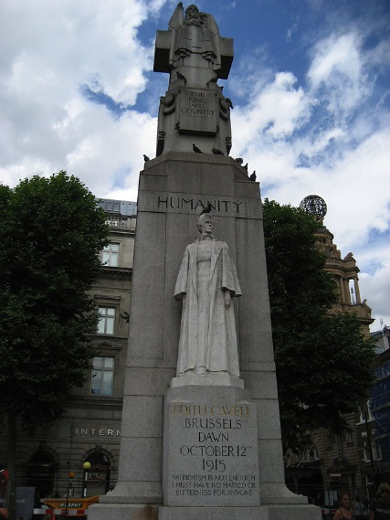
Anniversaries are seen as an opportunity to reflect on or celebrate the events in our lives. Wedding anniversaries allow us to remember that day in our lives when that younger, less wise, version of ourselves allowed temporary insanity to overcome us and lead us down the aisle… a short journey across a marital Rubicon beyond which our lives were changed forever. We can look at the photos and wonder ‘What were we thinking?’
For King and Country
Thurrock Writers’ Newsletter
August 2014
This year many of us will reflect on another bout of temporary insanity: one that gripped Europe and the world for over four years. Just as for a wedding anniversary, we can look back over the photos and ask the same questions. We can also wonder what happened to those wide-eyed innocents… except we know that for the poor souls between 1914 and 1918 it wasn’t two weeks in the Caribbean followed by twenty five years of mortgage payments.
From this month forward, and for the next four years, we can expect a procession of anniversaries: each one more bloody and heart wrenching than the last, and we can expect nearly as much ink to be shed now as blood during the conflict.
Those old enough to have experienced the war years, and still alive today, were no doubt children at the time. Those who fought and survived have long since passed on, but remembering their lives is important and writers will play their part in helping us to remember and understand the horrible beauty of those 51 months of war. Many of the books and articles that will follow will be, like the no man’s land between the trenches, land fought over many times without any great advance in our insight into the horrendous carnage that the world endured. But we can also be sure that other less well-known or forgotten stories will find their way into the public consciousness and through these we may come to know the people and their times better.
Stories like that of Edith Cavell who died for her ‘King and Country’ in Belgium in 1915 and to whom a memorial was raised after the war near Trafalgar Square: in sight of Nelson himself, such was the respect for her at the time. I myself have passed the unremarkable stone monument (pictured above) more times than I can mention, even on occasion glanced at it, but never, until now, taken the time to discover the woman to whose memory it was erected. If you do not already know her story then now maybe, you will be curious enough to discover her too.
However, Edith is not alone in being covered by the sands of time: countless stories of heroism and infamy wait to be unearthed. To be disinterred by the adventurous writer, to reveal both the good and bad in humanity.
Cry 'Havoc!'…
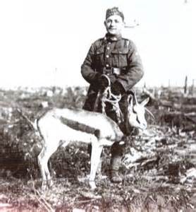
The war presents us with countless areas of inquiry: ‘Warhorse’ by Michael Morpurgo captured the imaginations of millions, and it is not surprising that much has been written of the role played by horses in the conflict. But is there one among us that will tell the story of the dogs that served, employed to, among other things, send despatches and also lay telephone cables and also the pigeons, used in their thousands to send messages around the battlefields?
In addition, let us not forget the mascots, many of which accompanied their regiments and ships into harm’s way and suffered the same hardships as the soldiers around them. There was ‘Tirpitz’ the pig, rescued from the sinking SMS Dresden to become mascot of HMS Glasgow, whose head now adorns the wall of the Imperial War Museum. And then there was ‘Winnipeg’ or ‘Winnie’ for short, a black bear mascot in the 2nd Canadian Infantry Brigade that was left at London Zoo on a ‘long-loan’ when the Brigade was posted to France. With the help of A A Milne he has gone on to entertain children for decades.
There are more stories to tell
Who will tell us of the Schrecklichkeit and the massacre at Aerschot? And who will shine a light on the 700 lost souls of the Saint-Michel-de-Maurienne derailment?
Will there be a writer who will cast their eyes to the Eastern front and tell us of the Czar’s army that, to the annoyance of their officers, cut down telegraph poles for firewood because they didn’t know what a telephone was and shot at their own aircraft because they didn’t believe Russia could possess such advanced technology?
The world needs writers to pass on these histories: so I urge you all to seek out the untold stories of 1914-18 and tell them.

The Women’s War
The Thurrock Writers’ Circle is comprised largely of women and so it might be natural for the majority of our members to have an interest in the impact of the Great War on women’s lives and the part that women played in the war.
Much has been written of the women’s contribution to the war effort but that is never a reason not to add more: indeed, it only goes to show the demand for information, and stories that carry the woman’s perspective. The past they say is like a foreign land and just as we might read a guidebook before venturing off on our holidays to some exotic location, we would do well to do the same before venturing into the wartime world of Edwardian women.
Below is a list of some useful titles that might illuminate the path of the curious writer, or the curious reader:
War Girls by Janet Lee
Fanny Goes to War by Pat (Waddell) Beauchamp
Testament of Youth by Vera Brittain
Rainbow Comes and Goes by Lady Diana Manners
The Roses of No Man's Land by Lyn Macdonald

Poet’s Corner

Violet Smythe
Typical wallflower Violet Smythe
Always a bridesmaid never a bride
Tall and skinny, straight as a pole
Great big feet, flat as a sole
Knobbly knees that clicked as she walked
Teeth in a brace that shone as she talked
Not much going for Violet Smythe
Till her blue eyes lit on the butcher’s boy
Then Violet began to use powder and paint
Her smile grew wide and her hair shone bright
She gazed at him and didn’t despair
Her charm just grew until one day
The man of her dreams came to carry her away.
Joy Ridgewell
Carpe Diem
This month we bring you the last of the competition details provided by Cindy Barber. Information she has made available to us, no doubt, in the hope that it will inspire us to put our own work forward, that it may be judged against the work of others… and who knows, we may just win something in the process. Let us not let her down.
Writers’ Village International Short Story Award – Winter 2014
Writers’ Village are asking for prose fiction of any genre up to 3000 words. The deadline is December 31st 2014 and the entry fee is £15 per story. This may seem a little high, but all entries receive feedback and so £15 for a critique suddenly doesn’t seem so bad. The first prize is £1000, with a second prize of £500, and a third prize of £250. Go to writersvillage.org.uk

2014 Chorley and District Annual Short Story Competition
Writers are invited to submit stories with the theme: ‘Your sins will find you out’. The deadline is September 30th 2014 and stories can be no more than 2000 words in length. First prize will be £100, second prize £50 and third prize £30. The entry fee is £5 per story or £8 for two. Go to wrekinwriters.co.uk
National Poetry Competition 2014
I know that the members of the Thurrock Writers’ Circle write purely for artistic satisfaction and have no ambition for financial reward… but with a first prize of £5000 it is hard to ignore the artistic satisfaction that would be yours if you won the National Poetry Competition 2014. Second prize is £2000 and third an insignificant £1000. The closing date is October 31st 2014 and the entry fee is £6 for the first poem and £3.50 for each subsequent submission. The poems may be on any subject and must not exceed 40 lines. Go to www.poetrysociety.org.uk
Labello, 3rd International Short Story Competition
Short stories of 5000 words or less with a closing date of December 31st 2014. The entry fee is 10 Euros per entry. First prize is 500 Euros, second prize 200 Euros and third prize 100 Euros. Go to www.LabelloPress.com
NAWG 2014 Open Competitions
Short Story and Poetry
The NAWG are asking for Short stories (between 500 and 2000 words) and poems (up to 40 lines) for their 2014 competition. The theme is open, but pieces must be ‘for adults’. I don’t think they’re expecting us to submit anything too explicit, just that they are ruling out works for children or in the YA genre.
The closing date is October 31st 2014. First Prize is £250, second £100 and third £50. The entry fee for both short stories and poems is £5 although there is also the opportunity to submit three poems for £10. There is also the option of paying an additional £5 in order to receive a critique of your entry.
Go to www.nawg.co.uk
The Charles Causley Poetry Competition 2014
Poems on any subject up to 40 lines in length. The closing date is November 6th 2014. First Prize is £2000, second £250 and third £100. The entry fee is £7 for the first poem and then £4 per subsequent poem on the same submission. Go to: www.thecharlescausleypoetrycompetition
Most Useful
Terry Brown has sent a most useful link to the Writers Online website where we may find a wide range of information and advice to help us progress as writers. The link is:
https://www.writers-online.co.uk/How-To-Guides
The Small Print
Find us online at: http://thurrockwriterscircle.weebly.com/
Newsletter submissions to: twcnewsletter@yahoo.co.uk
Poetry, Prose, News… anything wanted.

The Last Word
‘War does not determine who is right – only who is left.’
Bertrand Russell

