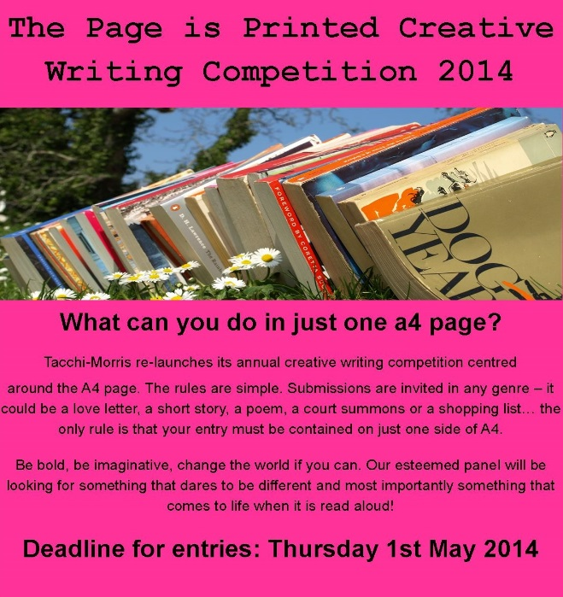

**£450 of prizes to be won!**

**Adult entry Fee for one entry: £4**

**Entry Fees (for up to 3 entries): Adults - £10, Under 16s - Free**

(Covers up to three submissions and includes a free ticket to The Page is Printed Open Mic Night on Friday 27th June at 7:30pm, where prize winners will be announced)

**Adult First prize: £200; Adult 2nd Prize: £100; Adult 3rd Prize: £50; Under 16: 3 prizes of £50 each**

**Entry Fees: Adults - £4 (one submission) / £10 (for up to three submissions) Under 16s - Free**

Entry fee includes free admission to The Page is Printed Open Mic Night on Friday 27th June at The Tacchi-Morris Arts Centre, where prize winners will be announced.

**Online:** You can pay your £10 Fee online. On completion of payment you will be given a unique Paypal code which needs to go on your entry form. Email your page and completed form to **thepageisprinted@gmail.com**

**By Post:** Send us your page and entry form along with a cheque payable to The Tacchi-Morris Arts Centre to The Tacchi-Morris Arts Centre, School Road, Taunton, TA2 8PD

**The Winchester Writers’ Festival**

Writers do not need to attend the Festival in order to enter: Deadline of 16 May, 2014 for submissions. A shortlist of top entries is posted at the Festival at 10:00 on Saturday, 21 June in the Stripe Building. First, second and third place winners are announced at 18:30 on the same day. In addition to their prizes, first place winners will be published in the festival anthology: *The Best of 2014*. This year the Festival is offering the following competitions:

Poetry  
Short Story  
First Three Pages of a Novel  
Flash Fiction  
Children’s Picture Book – aged 4-7  
Children’s Funny Fiction – aged 8-14  
Feature Article  
Memoir  
Writing Can Be Murder  
Writing for Children aged 8 – 12  
Young Writers’ Poetry  
Retirement

**The Small Print**

Newsletter submissions to: [twcnewsletter@yahoo.co.uk](mailto:twcnewsletter@yahoo.co.uk)

**Carpe Diem**

**The Bridport Prize**

General: Poems:  42 lines maximum, no minimum, the title is not included in the line count.  Lines between text/stanzas are not counted. Short stories:  5000 words maximum, no minimum, the title is not included in the word count. Flash fiction:  250 words maximum, no minimum, the title is not included in the word count.

All entries submitted can be on any subject, and written in any style or form. However, we do not recommend poems and stories written for children.

The deadline date for entries is 12 midnight (UK time) on Saturday 31st May 2014 (postal entries postmarked 31st May but received later will be accepted).

**Fees:** £7 for each submitted flash fiction; £8 for each submitted poem; £9 for each submitted short story

**Prizes:** The Bridport Prize will award the following prizes:

Poem: 1st prize £5,000, 2nd prize £1,000, 3rd prize £500, Highly Commended 10 x £50

Short story: 1st prize £5,000, 2nd prize £1,000, 3rd prize £500, Highly Commended 10 x £50

Flash fiction: 1st prize £1,000, 2nd prize £500, 3rd prize £250, Highly Commended 3 x £50.

**Cinnamon Press Short Story Competition**

The date for the short story moves to **May 31 2014.**

New prizes of £700, £150 & £50 + publication of the winners and up to 10 runners’ up stories.

There is a £12 fee and the judge is Vanessa Gebbie.

Open to all writers – published and beginners.

**The Fiction Desk Ghost Story Competition**

**The 2014 edition of our ghost story competition is now open!**

Most of the stories we publish at The Fiction Desk are more or less realistic, but we try to stray outside that from time to time: some genre fiction should be part of any balanced reading diet. One genre that we particularly like to feature is the ghost story.

This year, our ghost story competition has a first prize of £500, and *at least* five finalists will each receive £100; the winner and finalists will also be published in an upcoming Fiction Desk anthology.

Entries should be between 2,000 and 5,000 words in length. The entry fee is £7 for each story submitted, and the closing date is Friday, May 30th, 2014. Winners will be announced in late July.

The competition is judged by Rob Redman, editor of the anthology series and founder of The Fiction Desk.

Note: what counts as a ghost story?

'Ghost story' can mean a lot of different things, from an encounter with an actual phantom to more unusual paranormal phenomena and unexplained events. All types are welcome, so feel free to experiment: we're very unlikely to disqualify a story for stretching the definition of a "ghost". Keep in mind that our general readership (and by extension our judge) may be more likely to respond well to psychological chills and unexplained mysteries than in-your-face gore.

**The Frome Festival Short Story Competition**

Stories on any theme of between 1000 and 2200 words are invited. Entry fees are £5 per story and entry may be by post or online. The closing dated is 31st May 2014 and our guest judge this year is novelist Lesley Pearse.

"**A rose by any other name would smell as sweet**", or so Juliet would have us believe, but then I wonder if she ever stopped to smell the daffodils? This is the time of year we put aside for romantic notions of true love and yet it is marked by, thanks I fear to global warming, the first appearance of, and I shall be kind when I say this, one of the least fragrant flowers of this land.

Maybe it was the sight of newborn lambs that got ancient hearts stirring, but now we look out onto our gardens and it is the bright yellow organs of narcissus that greet us, that and the faint aroma of cat’s urine. How romantic is that?

**My World**

I stare at the earth, its battles and scars

At the screen on the Tele, of Jupiter or mars.

This planet is beautiful from way up in space.

From there you can’t see the scars on her face.

For people are hurtful, people are blind.

They cannot see, they do not mind.

When they laugh at the harm that they do to others.

Then cry, at the loss, of their own brothers.

No one should suffer the way that we do.

With no one to blame, but me and you.

I wonder, oh! Lord, what we do possess.

But, wait a moment, I do digress.

What if I see the joy that it brings,

To kill in such numbers, with a thing that has wings.

To see them rejoice at the maiming they do.

And then ask for help, from me and you.

They say there’s no food, but no one is thin.

Forgiveness my friend must come from within.

And at this moment as world war 3 has begun.

There is no joy there is no fun.

For every day a reminder is made.

On the TV screen or Wireless is played.

And if I live through this, I will be bound.

I will be scared like the earth all around.

Eva Rees

**To Quote…**

‘[To love oneself is the beginning of a lifelong romance](http://www.brainyquote.com/quotes/quotes/o/oscarwilde103614.html).’

Oscar Wilde

**When I Hear That Sound**

When I hear that sound,

My world is unclear.

It echoes from the walls all around.

And I know what it’s like to be Oh! So sincere,

When I hear that sound,

All the world becomes small.

A feeling so heady and round,

Or no feeling at all.

When I hear that sound,

I want to cry out, scream: shout.

But that makes a nonsense, rebound.

And all is but nowt.

The sound I refer too.

Above all else I fear.

It’s used as a healer. Clue

Silence! Yes Silence, far and near.

Eva Rees

**Puzzled?**

Last month Terry posed these problems for our members:

Using 4 matchsticks make them equal 10, now make them equal 20.

Here are the solutions: Roman Numerals VV= 10

Roman Numerals XX= 20

**Acrostics**

**Great English Poets**

**G**raves –Robert

**R**oxman—Susanna

**A**mis—Kingsley

**Y**eats—William Butler

**S**cott—Sir Walter

Terry

**English Writers (20th Century)**

**C**rawley—Alester

**H**icks—John

**A**damson—Joy

**D**onaldson—Julia

**W**heatley—Henry B

**E**dgar—David (playwright)

**L**ansbury—Angela

**L**awrence D.H. (David Herbert)

Terry

**The Last Word**

‘[Though lovers be lost love shall not.](http://www.brainyquote.com/quotes/quotes/d/dylanthoma109596.html)’

Dylan Thomas

**Feb ‘14**

**A Time for Romance**

**The Thurrock Writers’ Circle Newsletter October 2013**