**The Thurrock Writers’ Circle**

**Newsletter July ‘14**

**A Writers’ Progress**

The second Thurrock Writers’ Festival matched the success of the first with Thurrock Writers’ Circle’s members making substantial contributions in the form of Danielle Chinnon’s inspiring presentation and Cindy Barber’s workshop. Circle members busied themselves selling copies of the 2014 Anthology in between attending the varied presentations.

The perfect end to a tremendous day came when our own Cindy Barber was rewarded for her hard work with first place in the 1914 themed short story competition with an amazing piece on the assassination of Franz Ferdinand told from the perspective of the victim. The Circle’s well-earned congratulations are surely in order.

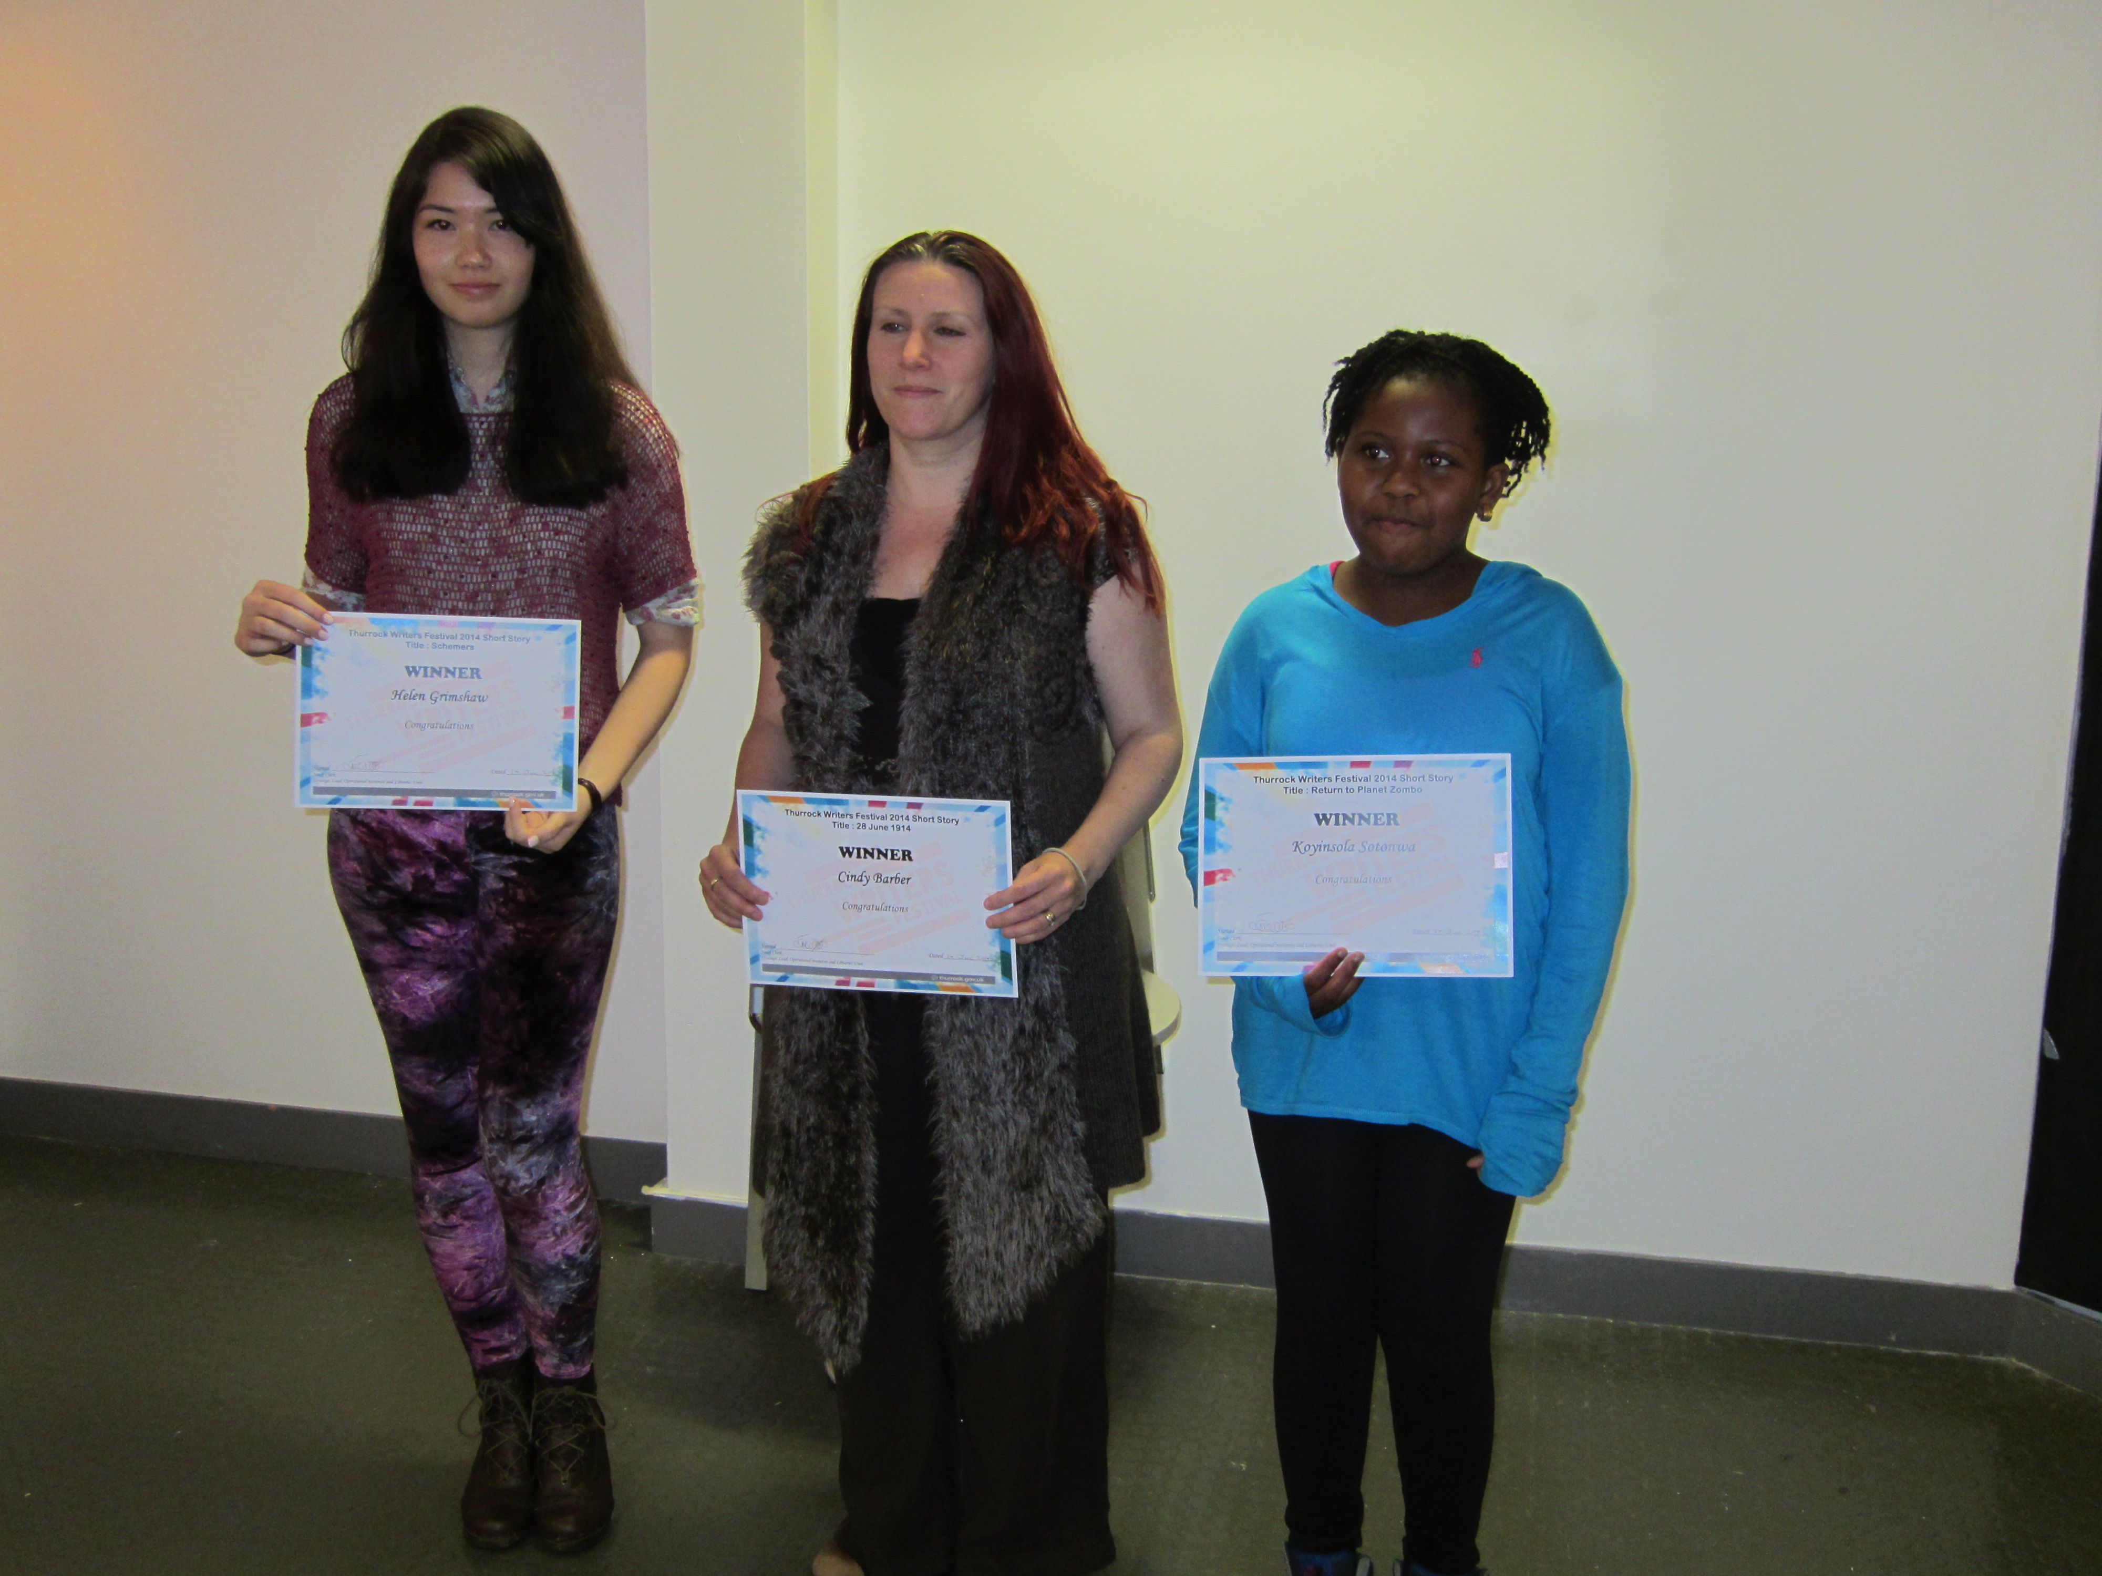

**The Usual Suspects: Cindy Barber (middle) insists she’s never met of Keyser Soze.**

Elsewhere Joy Ridgewell’s letter regarding a specific incident on her recent visit to Australia has been published in the Enquirer and the second installment of Danielle’s column has appeared in the Gazette as she awaits good news in August having entered three poems ('Aveley Days', 'Cupidity' and 'Oh Guardian Angel!') in the Mslexia 2014 Poetry Competition – Watch this space.

[http://www.flash500.com/index_files/image6962.jpg](http://www.flash500.com/index.htm)

[**Flash Fiction Competition**](http://www.flash500.com/index_files/flashfiction.htm)

**Now in its fifth year**, this quarterly open-themed competition for fiction up to 500 words has closing dates of 31st March, 30th June, 30th September and 31st December. **Entry fee:** £5 for one story, £8 for two stories. **Prizes:** £300 plus publication in [***Words with JAM***](javascript:Show('http://www.wordswithjam.co.uk/','newwindow','menubar=yes,toolbar=yes,location=yes,scrollbars=yes,resizable=yes,height=1150,width=1150')), £200 and £100

**The Small Print**

Find us online at: <http://thurrockwriterscircle.weebly.com/>

Newsletter submissions to: [twcnewsletter@yahoo.co.uk](mailto:twcnewsletter@yahoo.co.uk)

Poetry, Prose, News… anything wanted.

Summer: we have all been looking forward to summer. More so in some countries: in Japan for example, they have just celebrated Tanabata (meaning "Evening of the 7th"). Tanabata is a Japanese star festival, originating from the Chinese Qixi Festival. It celebrates the meeting of the two deities Orihime and Hikoboshi (represented by the stars Vega and Altair). According to Japanese legends, the Milky Way separates the lovers and they are only allowed to meet once a year on the seventh day of the seventh month.[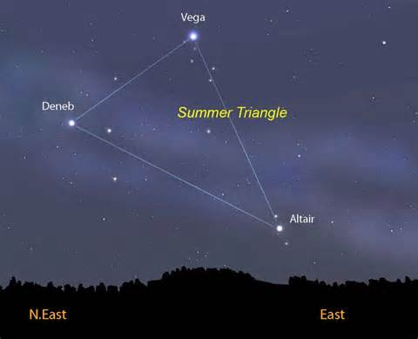](https://uk.images.search.yahoo.com/images/view;_ylt=A2KLj9ONF71TgxoAD.5NBQx.;_ylu=X3oDMTI0aHFvOXI5BHNlYwNzcgRzbGsDaW1nBG9pZAM1NDEzYTVjZjg1NzkxYWM1YWRiMTdiN2E5YWMzNTE1YgRncG9zAzEzMwRpdANiaW5n?back=http://uk.images.search.yahoo.com/search/images?p=altair+and+vega&_adv_prop=image&va=altair+and+vega&fr=yfp-t-403-s&spos=24&nost=1&tab=organic&ri=133&w=1024&h=831&imgurl=astrobob.areavoices.com/files/2013/05/Summer_Triangle-1024x831.jpg&rurl=http://astrobob.areavoices.com/tag/summer-triangle/&size=68.9KB&name=Get+cornered+by+the+Summer+Triangle+tonight&p=altair+and+vega&oid=5413a5cf85791ac5adb17b7a9ac3515b&fr2=&fr=yfp-t-403-s&tt=Get+cornered+by+the+Summer+Triangle+tonight&b=121&ni=128&no=133&ts=&tab=organic&sigr=11jqkj2r6&sigb=14lhi0npp&sigi=122am1vlq&sigt=11b8db675&sign=11b8db675&.crumb=G4ScoOyJTdc&fr=yfp-t-403-s)  
  
The date of Tanabata varies by the region of the country, but first festivities begin on July 7 and then celebrations are held on various days between July and August. The most famous Tanabata festival is held in Sendai from August 6 to August 8.

Tanabata was inspired by the famous Chinese Folklore story "The Weaver Girl and the Cowherd". This story goes as follows:

Orihime (the weaving princess) weaves beautiful clothes for her father, Tentai by the bank of the Amanogawa ("Heavenly river" or Milky Way). Her father was very proud and loved the clothes she wove. However, Orihime was sad that because of her hard work she would never meet anyone or fall in love. Tentai, concerned, arranged for her to meet Hikoboshi from across the Amanogawa. They fell in love instantly and were married.

Once married Orihime stopped weaving for her father and Hikoboshi allowed his herd of cows to stray all over Heaven (the river). Sadly, in anger Tentai separated the two lovers across the Amanogawa and forbade them to meet. Orihime became despondent; moved by his daughters' tears Tentai allowed them to meet again, but only on the seventh Day of the seventh month if she worked hard and finished weaving.

When they first tried to meet they found there was no bridge to cross the river. Orihime cried so that a flock of magpies came and promised to make a bridge with their wings so that she could cross the river.

It is said that if it rains on Tanabata, the magpies cannot come and the two lovers have to wait another year.

If you are thinking of going on holiday this summer, then I suggest going to Japan and enjoying the festivities that come with this romantic story. It is a popular custom to write a wish, hang it, along with other decorations, on bamboo and then either float the bamboo across river or burn your wish at midnight or the next day.

Shona Mawby

**Summer of Love**

**Carpe Diem**

The industrious Cindy Barber has provided us with a plethora of competitions, opportunities and tools:

**familyfriendpoem.com**

Thousands will read it if published by this e-zine. Work needs to be contemporary and have a wide appeal. There are many categories such as funny, sad, family, friendship, holiday, nature, spiritual and more. - make every word count -give the editor, through the sincerity of your words, a glimpse into your life. Submissions -via the link -poems reviewed by ten visitors -4 stars or higher are reviewed by editors - successful submissions are published on the main site. - can't send work already published on-line.

**i-Buzzle**

Short stories, poems, jokes, cartoons You don't get paid but editors claim it will help improve your literary reputation while receiving feedback from other writers. Engage reader through gripping content. Register on-line and you will get an email about how to set up an author page.

**Inksweatandtears.co.uk**

Publishes mostly contemporary free verse and prose poetry Aims to present something new every day. 4-6 submissions only in main body of the email or word file Send to [helen.ivory@ntlworld.com](mailto:helen.ivory@ntlworld.com). Include 30-40 line short biography. Read the guidelines.

[www.rhymer.com](http://www.rhymer.com/) for finding rhymes for words

[compsandcalls.com](http://www.compsandcalls.com) gives free of charge writing opportunities

[www.westegg.com/cliche](http://www.westegg.com/cliche) helps find out if what you've written is a cliché

[www.wordcounter.com](http://www.wordcounter.com/) Let's you paste get from your writing and it will show you the frequency of words in a piece.

[www.litlift](http://www.litlift) is a novel-writing package that guides you through creating scenes, characters, settings, plot lines. You can click and it will add random quirks and traits. Can get feedback for work from those on there. Free.

[www.grammarly.com](http://www.grammarly.com/) Paste text in and it will scan for grammar errors, spelling mistakes, problems with sentence structure etc. but it does cost.

[www.grammarly.com](http://www.grammarly.com/) Paste text in and it will scan for grammar errors, spelling mistakes, problems with sentence structure etc. but it does cost

**rangen.co.uk**

Generates plot, character etc. using random generators. Can request more detailed suggestions too or just get basic inspiration

**Take a break’s Fate and Fortune**

Looks for stories including/about ghosts, weird coincidences, fated love, and haunted houses. Get £50-400 depending on size etc. E-Mail jean.jollands@bauer.co.uk or web [www.fateandfortunemagazine.co.uk](http://www.facebook.com/l.php?u=http%3A%2F%2Fwww.fateandfortunemagazine.co.uk%2F&h=SAQFwauYP)

**Writer’s forum**

Monthly competitions – 1000 to 3000 words

www.writers-forum.com

£6 non subscriber, £3 subscriber

**Nottingham Open Poetry Competition 2014**

PRIZES: 1st: £300 2nd: £150 3rd: £75 and Ten Merit Prizes of £10.00. Closing Date: 12th August 2014. Poems should be no longer than 40 lines. Entry fee: £3.00 per poem or £10.00 for 4 poems. Entries should be addressed to: The Competition Secretary, 38 Harrow Road, West Bridgford, Nottingham NG2 7DU

http://nottinghampoetrysociety.wordpress.com/competitions/

**The 2014 Manchester Fiction Prize**

First Prize: £10,000   
Entry fee: £17.50   
Deadline for Entries: Friday 29th August 2014

The 2014 Manchester Fiction Prize will award a cash prize of £10,000* to the writer of the best short story submitted. All entrants are asked to submit a story of up to 2,500 words in length. The story can be on any subject, and in any style.

**The Manchester Poetry Prize 2014**

First Prize: £10,000   
Entry fee: £17.50

Deadline for Entries: Friday 29th August 2014

The 2014 Manchester Poetry Prize will award a cash prize of £10,000* to the writer of the poems submitted. All entrants are asked to submit a portfolio of three to five poems (total maximum line length: 120). The poems can be on any subject, and in any style.

For more information go to: www.manchesterwritingcompetition.co.uk

**Hysteria Writing Competition**

The **Hysteria Writing Competition** is now open for entries from women only and is accepting submissions in the short story, flash fiction and poetry categories. The competition closes on 31st August 2014.

* Short stories – 2,000 words maximum
* Flash Fiction – 250 words maximum
* Poetry – 20 lines maximum

Entry to the competition will cost £5 for short stories and £3 for poems and flash fiction.

PRIZES

* Short Story Winner – £150.00
* Flash Fiction Winner – £75.00
* Poetry Winner – £75.00

**Win £500 and publication with the Aesthetica Creative Writing Award!**

Aesthetica Magazine is inviting all writers and poets to submit their work into the Creative Writing Award. There are two categories for entry: Poetry and Short Fiction. Deadline for entering the award: 31 August 2014. Fiction entries should be no more than 2,000 words each. Poetry entries should be no more than 40 lines each. Each winner will receive £500. Go to <http://www.aestheticamagazine.com/creativewriting>

**The Short Story**

Welcome to The Short Story! The competition was set up in 2011. It is designed to showcase the best short stories from around the world. Three cash prizes will be awarded: First prize: £300, Second prize: £150, Third prize: £50. The deadline for submission: 15th September 2014. Word limit: 1,000-5,000 (maximum). Entry fee: £5 (via PayPal only). No poetry, novel chapters, sci-fi, fantasy or stories for children. Go to http://www.theshortstory.net/

**The Last Word**

Rest is not idleness, and to lie sometimes on the grass under the trees on a summer’s day, listening to the murmur of water, or watching the clouds float across the blue sky, is by no means waste of time. ~John Lubbock, "Recreation," *The Use of Life*, 1894