**A Writer’s Progress**

Danielle Chinnon has been busy preparing entries for various competitions, one of which required her to interview a musician. Here is her account of how it went:

When I had the opportunity to write about an Essex Musician, I knew who I wanted to write about straightaway.  I had first seen him perform at Thurrock Festival at Grays Beach some years ago (In fact, that has been the *only* time that I have seen him perform live), but his energy - his powerful onstage presence struck me.  I must have tucked him away somewhere in my memory banks, never suspecting that one day I would be writing about him.

So now, I had to retrieve that memory so that I could do a bit of research.  I remembered that he had a strange name: Tall...something...Horse? Stranger? Handsome?  I googled these possibilities: I was pretty sure that he hadn't been in a film directed by Woody Allen, and doubted he had had a No. 1 hit in 1969 in Canada and the USA - the young guy I'd seen on stage clearly wasn't in his forties!  Finally, his name came up: Tall Dark Friend.  Ah yes!  I remember now!

I gleaned what I could from his web site.  But it wasn't enough.  I had an idea:  how much more interesting my piece would be if I could interview the man himself.  But how to contact him?  I followed the instructions on his web site and sent a polite enquiry.  After a couple of weeks I scratched my head again:  I wondered if Michael Casey of Your Thurrock might be able to help me; after all had he not referred to Mr. Tall Dark Friend as 'a diamond talent in a world full of cubic zirconium'?

The conversation went something like this:

Hmm… Hello Mr. Michael Casey, my name is...we met before..."

"Oh yes, I remember.  How are you?"

"I'm very well thank you and yourself?"

Fine thanks.  How can I help?"

"Well..."

And so, thanks to Mr. Casey, I was able to make progress.  I contacted Tall Dark Friend, explained my task and we met a couple of weeks later at the Thameside Theatre.

After the introductions, we settled down in a quiet spot where we wouldn't be disturbed.  Now, while I hadn't expected to come face to face with his onstage persona, I was still surprised by his calm, easygoing manner; and he got instant brownie points when he came to the rescue in sorting out a faulty vending machine!   I turned on my recorder and Mr. Jordan Gray - his real name - took me on a musical journey of - dare I say - corridors and opening doors.  Amazing!

Mr. Gray was a delight to interview.  I thought him very polite and gentlemanly.  I would like to know him more, if only to experience that well developed sense of humour that I suspect he has.

**The Small Print**

If you have a submission for the Cristmas Short Story competition get it to Joy Ridgewell now.

Newsletter submissions to: [twcnewsletter@yahoo.co.uk](mailto:twcnewsletter@yahoo.co.uk)

**Carpe Diem**



**Crime stories up to 2,000 words may be entered for the contest, which offers cash prizes and publication to the winners.**  
The first prize is £100, the second £50, and the third, £25. The winners and seven runners-up will be published in a GKBC Inc. anthology.  
There is no entry fee. The closing date is 31 December.  
[The GKBC International Short Story Competition](http://gkbcinc.com/the-gkbcinc-short-story-competition/) runs twice each year. The winners of both 2013 competitions will be published in March 2014.

Submitted by Terry

**The Fiction Desk - Flash Fiction Competition**

Apparently regularly approached by authors whose stories are too short to fit into their regular anthology series. In order to accommodate some of these shorter works, and provide more variety for their readers, they run an annual flash fiction competition.

The competition is open now. The first prize is £200 and there are four runner-up prizes of £25; the winner and runners-up will also be published in an upcoming Fiction Desk anthology.

Entries should be between 250 and 1,000 words in length. The entry fee is £3 for one story or £7.50 for three stories submitted together, and the closing date is January 31st, 2014. Winners will be announced late February 2014.

The competition will be judged by Rob Redman, editor of the anthology series and founder of The Fiction Desk.

Entrants might find it helpful to read last year's winners, published in our anthology [*Because of What Happened*](http://www.thefictiondesk.com/anthologies/because-of-what-happened.php).

To Enter

To enter the competition, or to view their full terms of entry, please visit one of their two online forms to be found at:

http://www.thefictiondesk.com/submissions/flash-fiction-competition.php

**The Last Word**

‘A desperate disease requires a dangerous remedy.’

Attributed to Guy Fawkes – the disease being King James I.

To the list of things that wait for no man, ‘time’ and ‘tide’ now find themselves in the company of ‘technology’. In an age where traditional publishing appears to be rapidly becoming a thing of the past, it is now incumbent on authors to have a ‘web presence’.

Many of us, no doubt, already use social media in our everyday lives: a Facebook page has become almost essential. Maybe some amongst us are ‘Linkedin’ while others may well ‘tweet’ on a regular basis. If all of this doesn’t consume enough of your time, then possibly you have your own ‘blog’ (Wordpress being a popular choice for authors) and finally should you have the inclination you can open your own website.

All of this sounds incredibly daunting and time consuming. However, if we are serious about our writing, then it behoves us to board the good ship Technology and not miss the tide that is sweeping away ‘Old Publishing’ and creating a brand new world for us to venture in to.

  ?

Individually we’ll all make our own decisions, but as a group it might be wise to discuss the options open to us and ask ourselves first the fundamental question: Does TWC want or need its own online presence? Currently we have space on the Thurrock Arts Council website, but is this enough?

Assuming that we have answered that question in the affirmative, we must then ask what we want from our online domain. Would we be happy with a TWC Facebook page or would we want our own web site?

This month’s issue of the Writing Magazine has, coincidentally, a very informative article about the different website providers (Moonfruit, Yola, Wix, Weebly and Webs) out there and a comparison of their services.

Essentially, do we want the outside world to see us and what do we want them to see?

I urge all members to give this issue some thought and then put your ideas to the pen and submit them (at twcnewsletter@yahoo.co.uk) for publication in the December Newsletter. I, for one, am very interested to hear what you all have to say.

Let the debate begin!

**Pound Saver**

The TWC meeting of the 30th of October was attended by Patricia Pound who very kindly agreed to speak to the group.

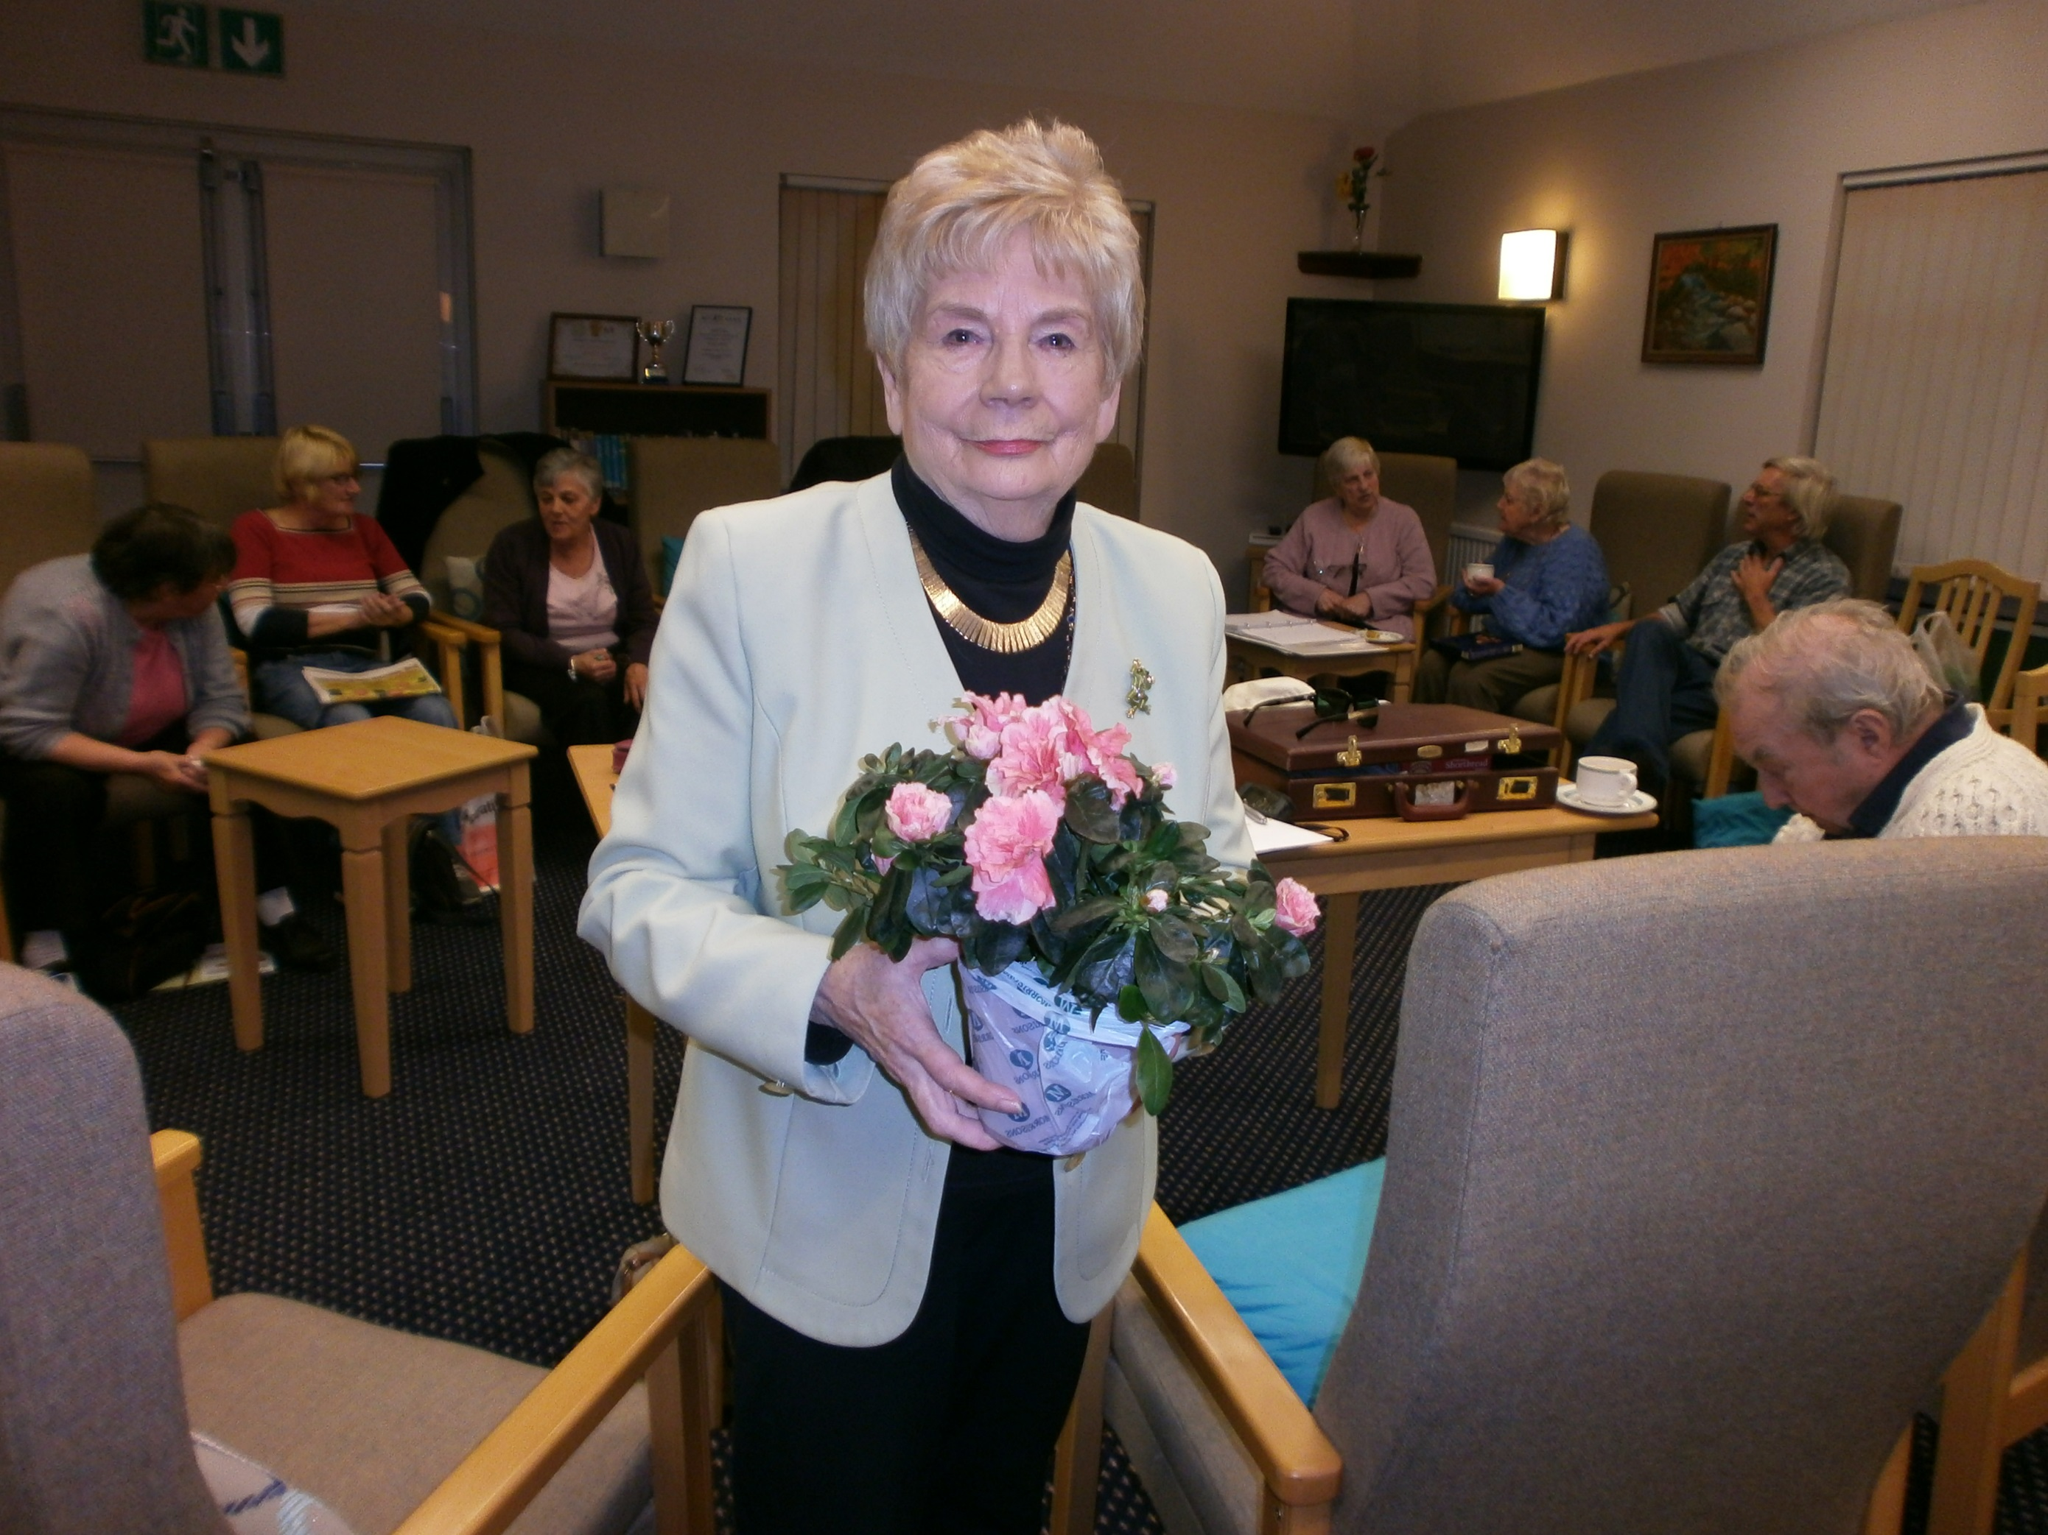Patricia Pound with flowers and our thanks.

Reports are that a thoroughly entertaining presentation was received and Ms. Pound has sent her thanks for the very warm reception that was given.

**A Good Read**

TWC members are welcome to share with us what they are reading. This month Danielle Chinnon tells all:

I'm just responding to the invitation to share current reading. I'm actually taking a break from reading C. J. Sansom. I lost a lot of sleep over him and for all the right reasons!

It all started with a 20p novel 'Dissolution'. From the first page I was transported to the sights, sounds and smells of Tudor England, accompanying Matthew Shardlake the sharpest lawyer in London - if not England - on his crime-solving assignments. This led to 'Dark Fire' and 'Sovereign', so for several months I spent most of my nights in Tudor England.   I've yet to read the fourth in the Shardlake series, 'Revelation' which I hope it will be!

Danielle.

**Grave Words**

A friend recently buried his mother-in-law in the same grave as her husband. The headstone was removed so her details could be added. On top of the fixed costs, my hard-up friend has learned there will be a charge of £5-a-letter. So far has got it down to: & WIFE :(

Submitted by Joy Ridgewell

**Nov ‘13**

**Wait For No Man**

**The Thurrock Writers’ Circle Newsletter October 2013**