**A Writer’s Progress**

Fortunately one of our number has been labouring hard, over the summer months, on her second great work. Not that we would want to ignore the vital role her husband, Ash, has played in all of this, but we understand that Cindy has suffered for her art. We know for certain that this next ‘as yet untitled’ addition to the Barber family will be as great a masterpiece as the first. Apparently due out in March 2014, we await delivery and all wish Cindy, Ash and Michael our best wishes and heartiest congratulations.

**The Proof of the Pudding**

Philippa Barr, an Essex based journalist, offers proof reading services to writers looking to add polish to their manuscript.

Ms. Barr states that she is ‘full of admiration for anyone who can harness their creative juices and then put in the hard work necessary to write works of fiction, so if someone is prepared to - and has the budget to - go the extra mile by hiring a proof-reader as part of the finishing touches, that says a lot about their commitment to their project.’  
Philippa has 37 years' experience as a journalist/copy-writer/proof-reader in many different fields and offers meticulously high standards of spelling and grammar. As part of the proof-reading process she also acts as a 'continuity editor’ fishing out the anomalies in the text. She welcomes anyone to contact her for a friendly, no-obligation, exploratory chat.

Philippa can be contacted at:

SunSign Communications Limited: 01277 221701 and 07890 756698

[philippa.barr@tiscali.co.uk](mailto:philippa.barr@tiscali.co.uk)

[www.sunsigncommunications.co.uk](http://www.sunsigncommunications.co.uk/)

Twitter: @PhilippaSunSign

Blog: [http://philippasunsign.wordpress.com](http://philippasunsign.wordpress.com/)

**Three Flashes of Inspiration**

The frog hid underneath his favourite leaf. The rain had made everything wonderfully squelchy, ideal for making wet slippery stones and filling ponds, for hopping into.

There were rumours circulating however and he had to be very careful to preserve this lifestyle he loved.

He could think of nothing worse than being captured, kissed by a princess and turned into a prince! **Mary Vear**

The job advertisement called for a ‘high flyer.’ He knew that he had the right qualifications. An interview was arranged and he dressed carefully to make a good impression. Later the interviewer looked in disbelief at the long red cape, tights and large ‘S’ symbol emblazoned on the shirt before him. Actually, he thought, Superman was slightly overqualified for the position. **Mary Vear**

The rain stopped and a rainbow appeared. The little boy ran into the garden to see where it had landed. He returned quickly saying ‘I’ve found it.’ Taking hold of his mother’s hand he led her to a large puddle near the shed. On top of the water’s surface glistened an array of colours caused by petrol leaked from the mower. **Mary Vear**

**The Small Print**

Let’s get the dates for TWC meetings right this time: Oct 2/16/30, Nov 13/27, Dec 11, and 2014 starts on Jan 8th. November 13th will take place at the Chadwell Forum meeting.

Newsletter submissions to: [twcnewsletter@yahoo.co.uk](mailto:twcnewsletter@yahoo.co.uk)

**Carpe Diem**

**Harpers Bazaar Short Story Competition**: for original literary short stories, up to 3,000 words, on the theme of ‘Spring’. Win: publication in Harper’s Bazaar (payment at pro-rates), a first edition of a book of your choice from Asprey’s Fine Books, plus a week long retreat on the Scottish private island where JM Barrie wrote Peter Pan. Free entry. Closing date: Dec 13th. Website: [www.harpersbazaar.co.uk](http://www.harpersbazaar.co.uk)

**Willesden Herald Short Story**: for short stories up to 7,500 words. First prize £300 (2x runners-up £150 each). Entry Fee: £6. Closing date: Dec 20th. Website: www.willesdenherald.com

**More of Our Own Words**

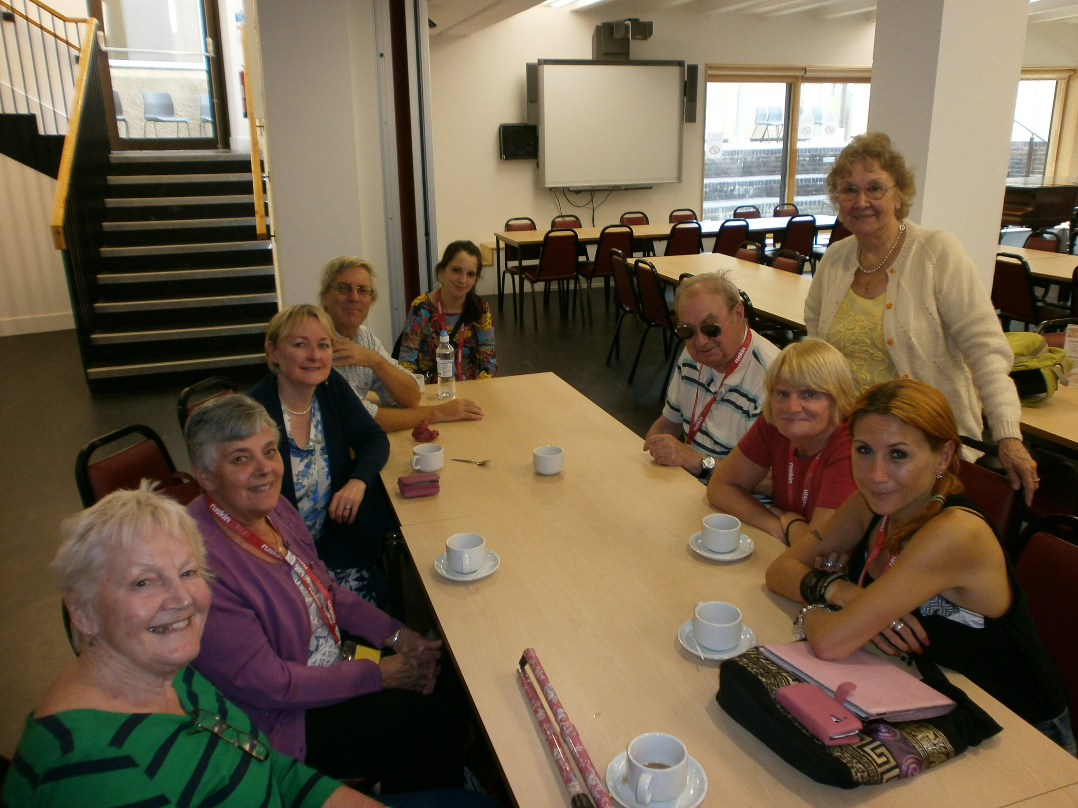

The Thurrock Writers' weekend trip to Ruskin College, Oxford, was well received by everyone in the group. Much was learnt and tips gained throughout the course. Food was not of satisfactory order by some but, in general, the group found the meals good enough. All in all a fine weekend was had by the Circle. **Steve D**

Seven of us set off by minibus, with high hopes, to Oxford to spend a weekend with a tutor who would help us to go forward with our writing. (Two more members travelled by car, making nine in total.

Ours seemed to be the only tutorial class in the college, which was strangely quiet when compared to Belstead House, where several groups (Lace making, Art, etc.) were going on at the same time. However we met out tutor, Helen, and had our first meal – not very exciting, but we hoped for better things later.

Helen proved to be an excellent tutor and we were able to learn a lot from her, making our journey worth-while, but I wouldn’t go again as the food left a lot to be desired, excepting breakfast, which was better with more choice. Perhaps we were spoilt at Belstead House, having a nice restaurant for a good breakfast, lovely buffet lunch and a good dinner, plus lots of coffee and tea and biscuits in between tutorials. However, you can’t have everything, and our tutor was well worth the visit**. Barbara**

What could we hope to learn in two days? Our strict governess, Ms Mosby, reminded us of a few fundamentals: ‘show don’t tell’, eschew adjectives and adverbs, keep it lean, but some other points were emphasized: fiction is dramatic – beyond the everyday, and keep dialogue uncluttered. Maybe the most useful idea was the simplest: ‘What if?’ Take any situation and ask: how would this change if …and thus create a story. The TWC members performed superbly: with each new piece setting the bar a little higher …sadly beyond my reach. Two days with TWC taught me how good they are, how little I know, and the value of a good teacher. **Steve G**

On the 20th September I became an honorary member of the Thurrock Writers’ Circle for a weekend, and joined them on a residential writing course held at Ruskin College in Oxford. The weekend course started on the Friday evening, and our tutor, Helen, was fantastic. The weekend was informative, interesting, and everyone seemed to feel improvement and progression. Despite a few hiccups here and there, it was a great weekend, and I would definitely repeat the experience! **Vicky**

**The Last Word**

Here are some of the titles recommended during the course of the weekend:

The Garden Party and Other Stories – **Katherine Mansfield**

Everything Ravaged, Everything Burned – **Wells Tower**

The Road – **Cormack McCarthy**

The Playboy of the Western World – **J M Synge**

Talking Heads – **Allan Bennett**

And finally absolutely anything by **Anton Chekov**.

‘**In Medias Res’**

Horace (Care of Helen Mosby)

**In Our Own Words**

Here are the impressions of some of the TWC members who attended the course.

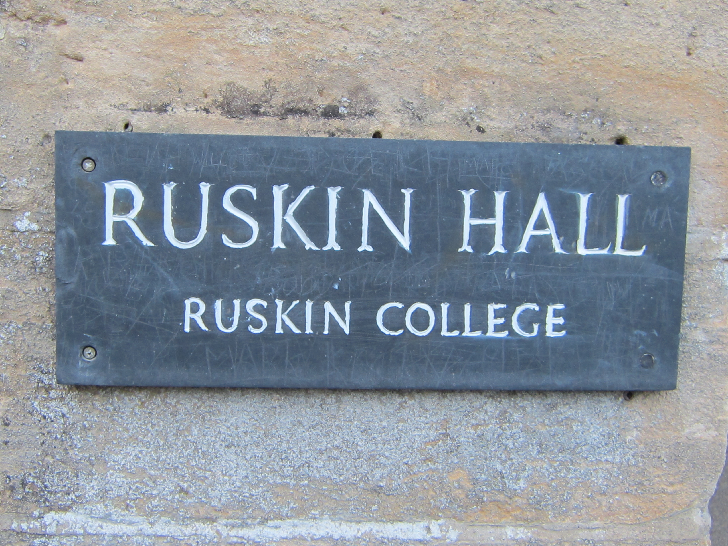

Our weekend at Oxford was a great learning experience; I think everyone came up to the challenge that our tutor, Helen Mosby, presented us with. It was Helen's birthday on the Saturday and she brought a chocolate cake to share with us.   
We had some delay in arriving and Irene and Vicky were tucking into their meal when we arrived. I have to commend Peter; he has a lot of things against him, mainly being partly sighted, but he is undaunted. Thanks to Steve Grimshaw for the help he gave to Peter and for the wine he got for us and as a thank you for Helen. Steve Davis also was there to lend a helping hand with the cases and helping Peter, also feeding the College cat that looked a lot happier when it was given the meat too tough for us to eat.   
Mary was pleased to have a young man come to her rescue with an air freshener when her room proved to have a pong. Shona was unwell but soon came back to join in with everyone. Steve D sneaked a crafty coffee, although the kitchen staff told us we had to pay for the privilege: £200 plus wasn't enough?  
Poor Barbara couldn't get the shower to work maybe she needed the young man with the air freshener to help out. As for me I was on a roll and have plenty to work on, and I found our whole group have been a pleasure to go with.  
Our only downer was not everyone enjoyed the food. But, hey, what can you do? I did make a casserole on Monday just to prove that I could make a nice fluffy dumpling. We will have to look out for a further venue, but maybe a bit nearer, next year.  **Joy**

On Friday September 20th. 8 members of Thurrock Writers' Circle went on a weekend short writing course at Ruskin College, Oxford.  
Disappointingly the college is no longer situated at St. Giles but in a converted manor house in Headington on the outskirts of the city, however it is set in a very nice campus of lawns and established trees.  
Unfortunately the catering was not as good as it could have been, possibly because it was out of term time and temporary staff replaced the regularly staff.  
The accommodation was adequate in a typical student style. The only unusual thing about it was the lighting was all motion activated, so if one stood still the lights went out!  
However Helen, the tutor, was excellent and kept us fully occupied with exercises and challenges, covering the main aspects of fiction writing; characterization, setting, dialogue and plot.  
 The group acquitted themselves very well and all agreed that they had gained from the experience. **Peter**

**Oct ‘13**

It was a real pleasure to spend the weekend with a group from your Writers' Circle. I was asked to put together a summary of tips from the course, so here is a list of 'what to look for in your stories'. It only remains for me to say a big thank you to Peter, Joy, Steve D, Mary, Barbara, Irene, Shona, Vicky and Steve G for visiting Oxford and producing some wonderful writing.

What to look for in your stories

Your objective as writers is to invite your readers into the world of your stories so that they forget that they're reading and feel that they're there - in the kitchen with the warring couple; in the trench with the young soldier about to go over the top; on the same train as the girl who's about to meet the dangerous stranger. To this end, here are some questions to ask of your story once you've written your first draft:

Has the story got a central conflict? Look at where this conflict lies and what it consists of.

Does the central character have a backstory? Do we find out what this is during the course of the piece?

Has the character's current situation in the story evolved out of this backstory?

See if the central character undergoes a shift of some sort during the story.

Do we see what the effect of this shift might be? You need to leave room to show this - i.e. the shift shouldn't happen in the last sentence.

Look at whether the timeframe of the story is manageable for a piece of short fiction.

Is there a limited number of characters? Two or three is ideal.

Will there be interaction and conflict between the characters?

Will there be plenty of opportunity for dialogue?

Which point of view might work best for this story?

Think about how the setting of the story and in what way it will feature.

Might we see this setting through the central character's viewpoint (in the way we did in the class exercise)?

Think about the structure of the story, and about the difference between plot and structure. In other words, the events might be revealed to the reader in a non-linear way.

How will the story open? See if there's a strong hook for the reader at the beginning which will keep us on board.

When is the story set? How is this indicated?

What theme/s are being explored in the piece?

Might there be scope for contrast in the story - for example in the pacing?

Helen Mosby

**Oxford by Degrees**

**The Thurrock Writers’ Circle Newsletter October 2013**